**Beet Seed** **1**

| **Test Case ID** | **Title** | **Priority** | **Test Type** | **Preconditions** | **Steps** | **Expected Result** |
| --- | --- | --- | --- | --- | --- | --- |
| TC1 | Test redirection to sale of cars of a specific brand | High | Functional | NA | * Open the website <https://www.carsforsale.com/> * On the “Cars for Sale By Brand” section click on any brand | The user is redirected to the page with only cars from the selected brand for sale |
| TC2 | Test search by payment conditions | High | Functional | NA | * Open the website <https://www.carsforsale.com/> * Select a minimum and maximum pay from the list * Select a minimum and maximum year * Select the miles * Input the zip code * Click on the button “Find Yours” | The user is redirected to a page that shows only cars for sale that comply with the selected parameters |
| TC3 | Check if the user can create alert without inputting the email address | High | Functional | NA | * Open the website <https://www.carsforsale.com/> * Click the “Create Alerts” button on the Shopping Alert banner * Select the Make, Model, Min and max year, Min and Max price, zip code and miles * Leave the “Send alert to” field blank * Click on “Create Alert” | A error message appears indicating that the user cannot create an alert without inputting a valid email address |
| TC4 | Test the “Favorites” button without login in | High | Functional | The user should not be logged in | * Open the website <https://www.carsforsale.com/> * Click on “Favorites” on the website header | A window for login in appears |
| TC5 | Check social media link | High | Functional | NA | * Open the website <https://www.carsforsale.com/> * On the website footer click on any social media link in the “Follow us” section | A new tab opens with the Cars for Sale social media page selected |

**Beet Seed 2**

Detected Bugs:

| **Bug ID** | B1 |
| --- | --- |
| **Title** | Created user is not added to the User list |
| **Description** | After creating a new user using the POST Method, the user doesn’t appear on the list of users when using the GET method |
| **Environment** | Lenovo ThinkPad; Windows 10 Pro; Google Chrome Version 115.0.5790.173 |
| **Steps to Reproduce** | Create a new user using the POST method on the link <https://reqres.in/api/users>: on the body insert name and job in json;  Take note of the Id assigned to the new user;  Consult a list of users using the GET method on the link <https://reqres.in/api/users/> followed by the id of the new user created |
| **Screenshots** | Below |
| **Expected Result** | The new user information is shown |
| **Actual Result** | The user is not found - 404 error |

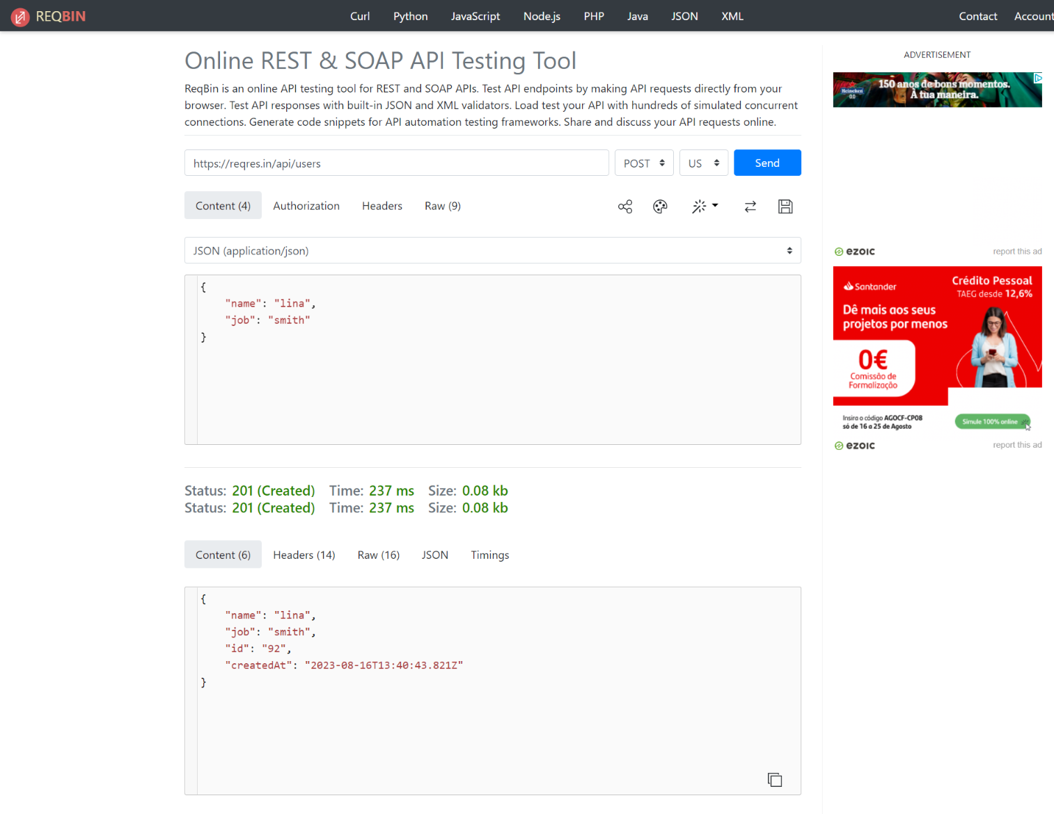

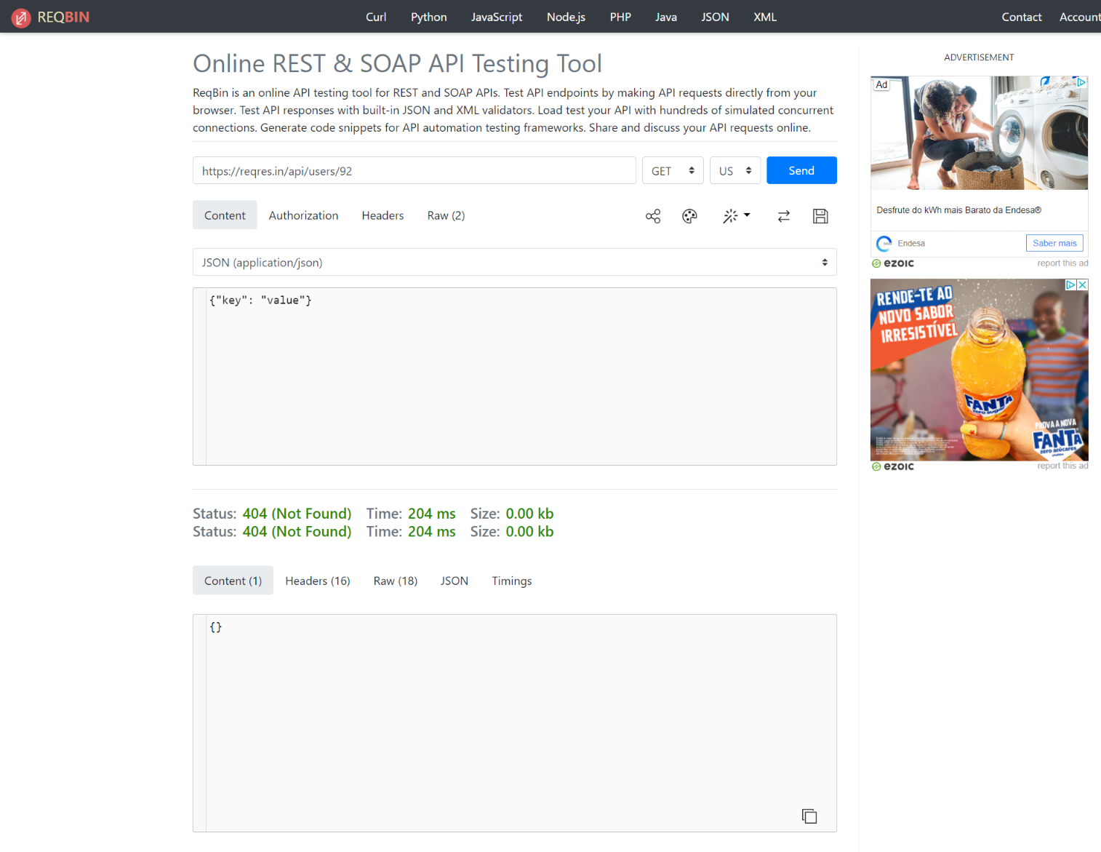

| **Bug ID** | B2 |
| --- | --- |
| **Title** | User’s information is not updated |
| **Description** | After updating an user’s info using the PUT method, the user’s information stays the same |
| **Environment** | Lenovo ThinkPad; Windows 10 Pro; Google Chrome Version 115.0.5790.173 |
| **Steps to Reproduce** | Consult any user’s information using the GET method in the link <https://reqres.in/api/users/>{user’s ID};  Update the user’s name and job information using the PUT method on the link <https://reqres.in/api/users/> {user’s ID} using the user’s ID previously selected  Consult the user’s information again using the GET method on the link <https://reqres.in/api/users/> {user’s ID} |
| **Screenshots** | Below |
| **Expected Result** | The information should be updated to include the name and job inputted |
| **Actual Result** | The user’s information remains unchanged |

User info before change:

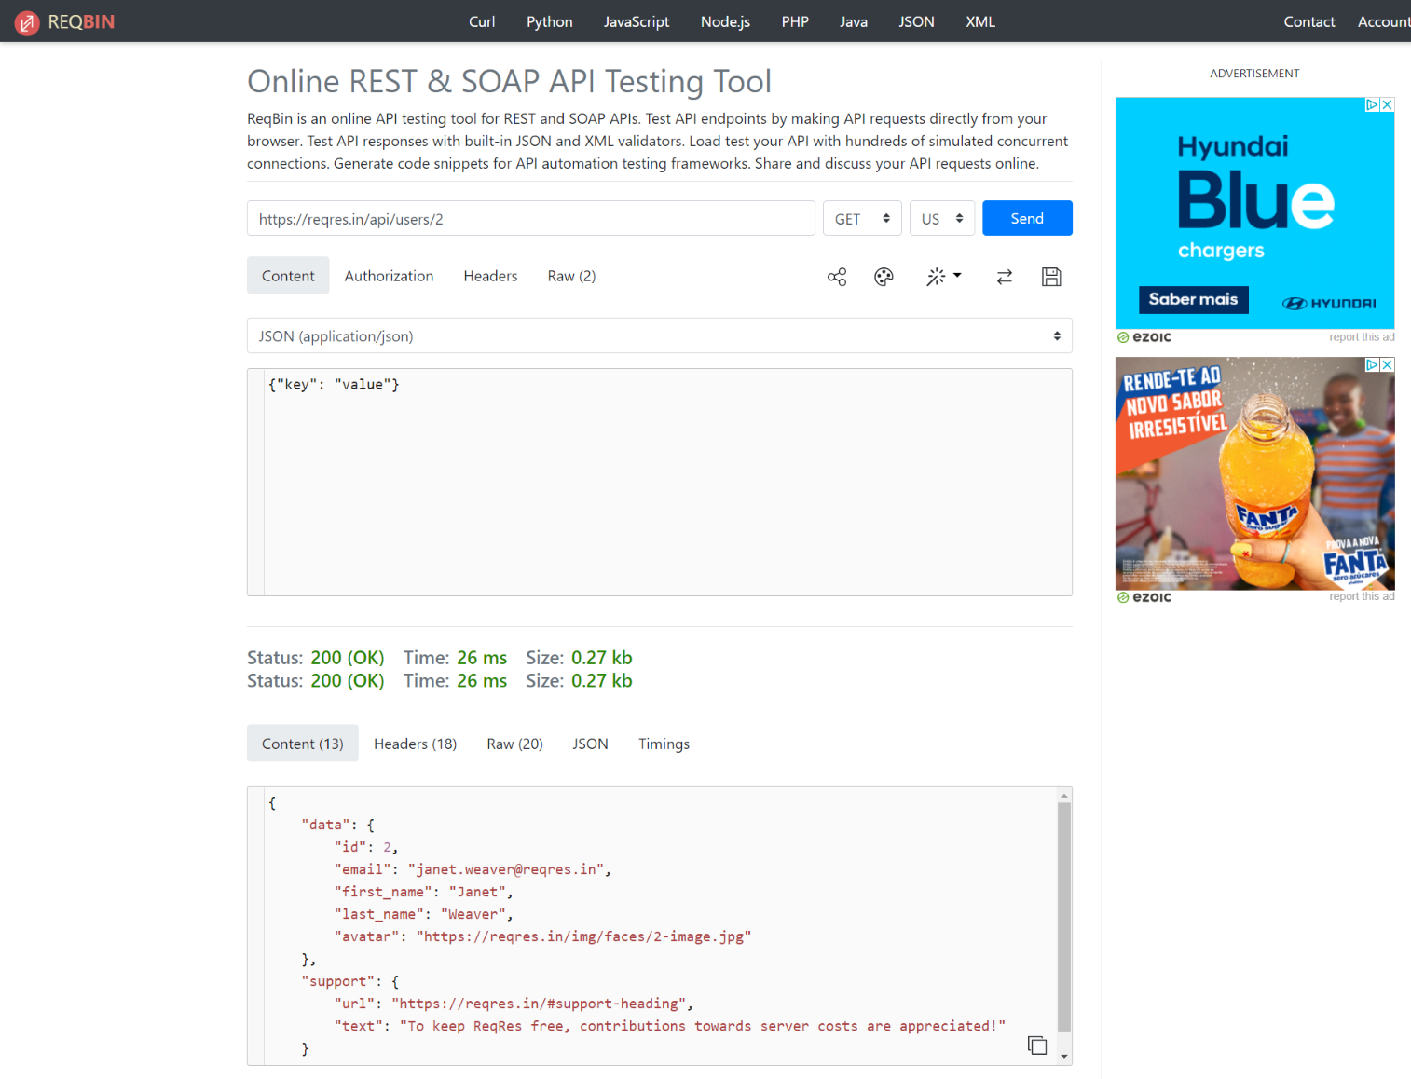

User’s info update:

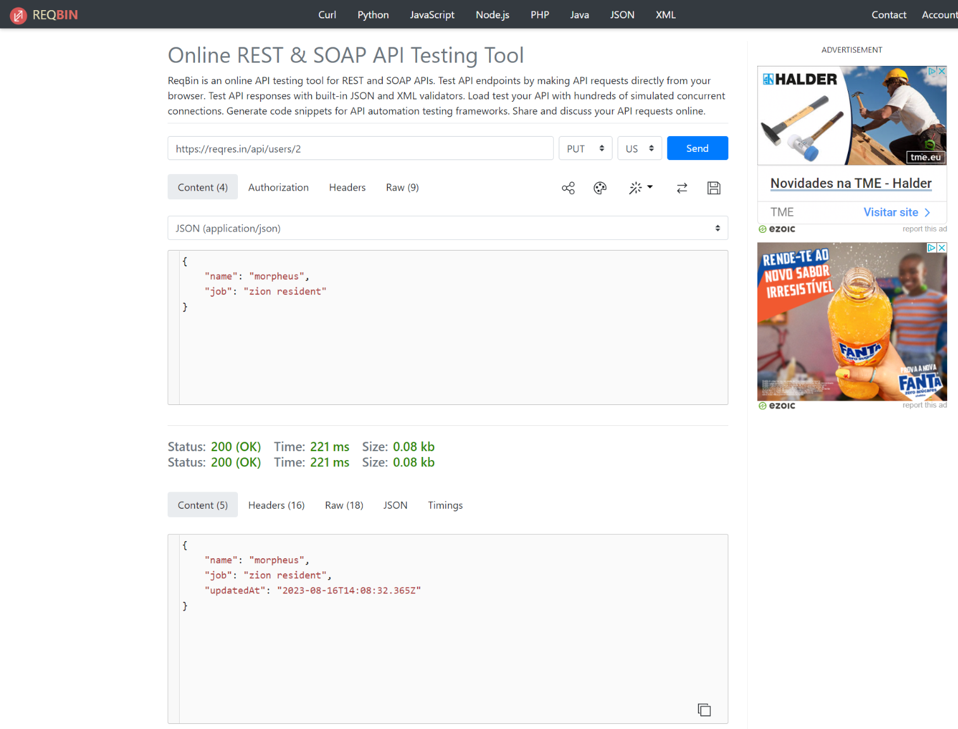

Users info after update (by PUT method):

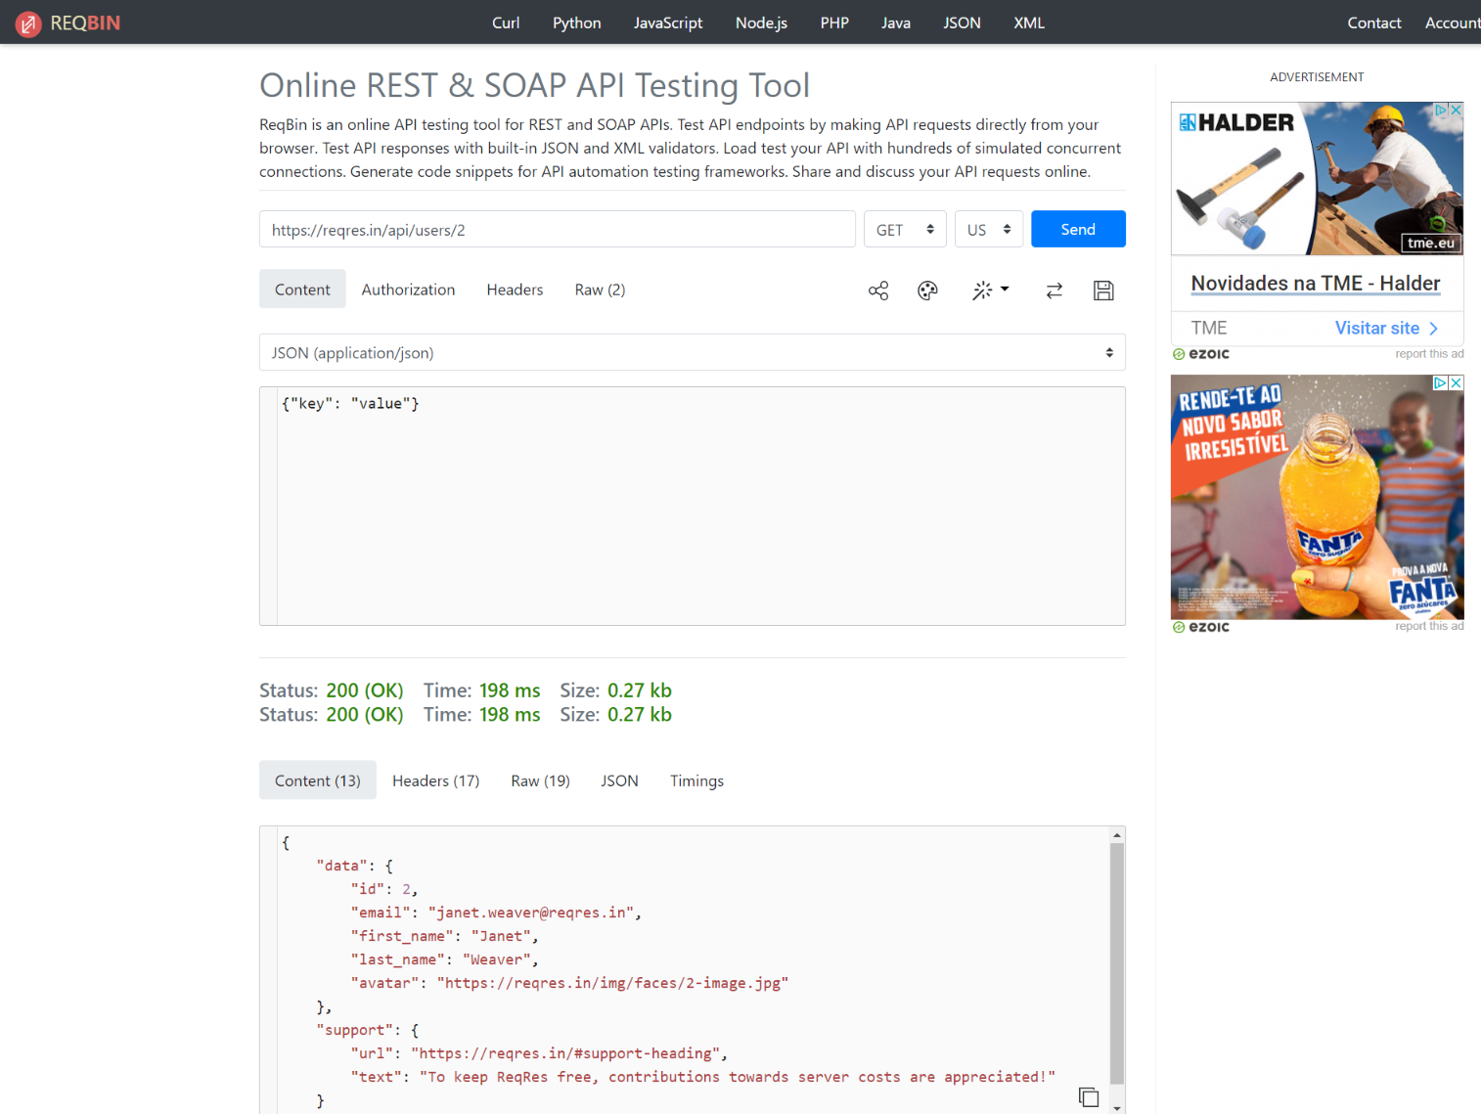

| **Bug ID** | B3 |
| --- | --- |
| **Title** | User’s information is not updated |
| **Description** | After updating an user’s info using the PATCH method, the user’s information stays the same |
| **Environment** | Lenovo ThinkPad; Windows 10 Pro; Google Chrome Version 115.0.5790.173 |
| **Steps to Reproduce** | Consult any user’s information using the GET method in the link <https://reqres.in/api/users/>{user’s ID};  Update the user’s name and job information using the PATCH method on the link <https://reqres.in/api/users/> {user’s ID} using the user’s ID previously selected  Consult the user’s information again using the GET method on the link <https://reqres.in/api/users/> {user’s ID} |
| **Screenshots** | Below |
| **Expected Result** | The information should be updated to include the name and job inputted |
| **Actual Result** | The user’s information remains unchanged |

User info before change:



User’s info update: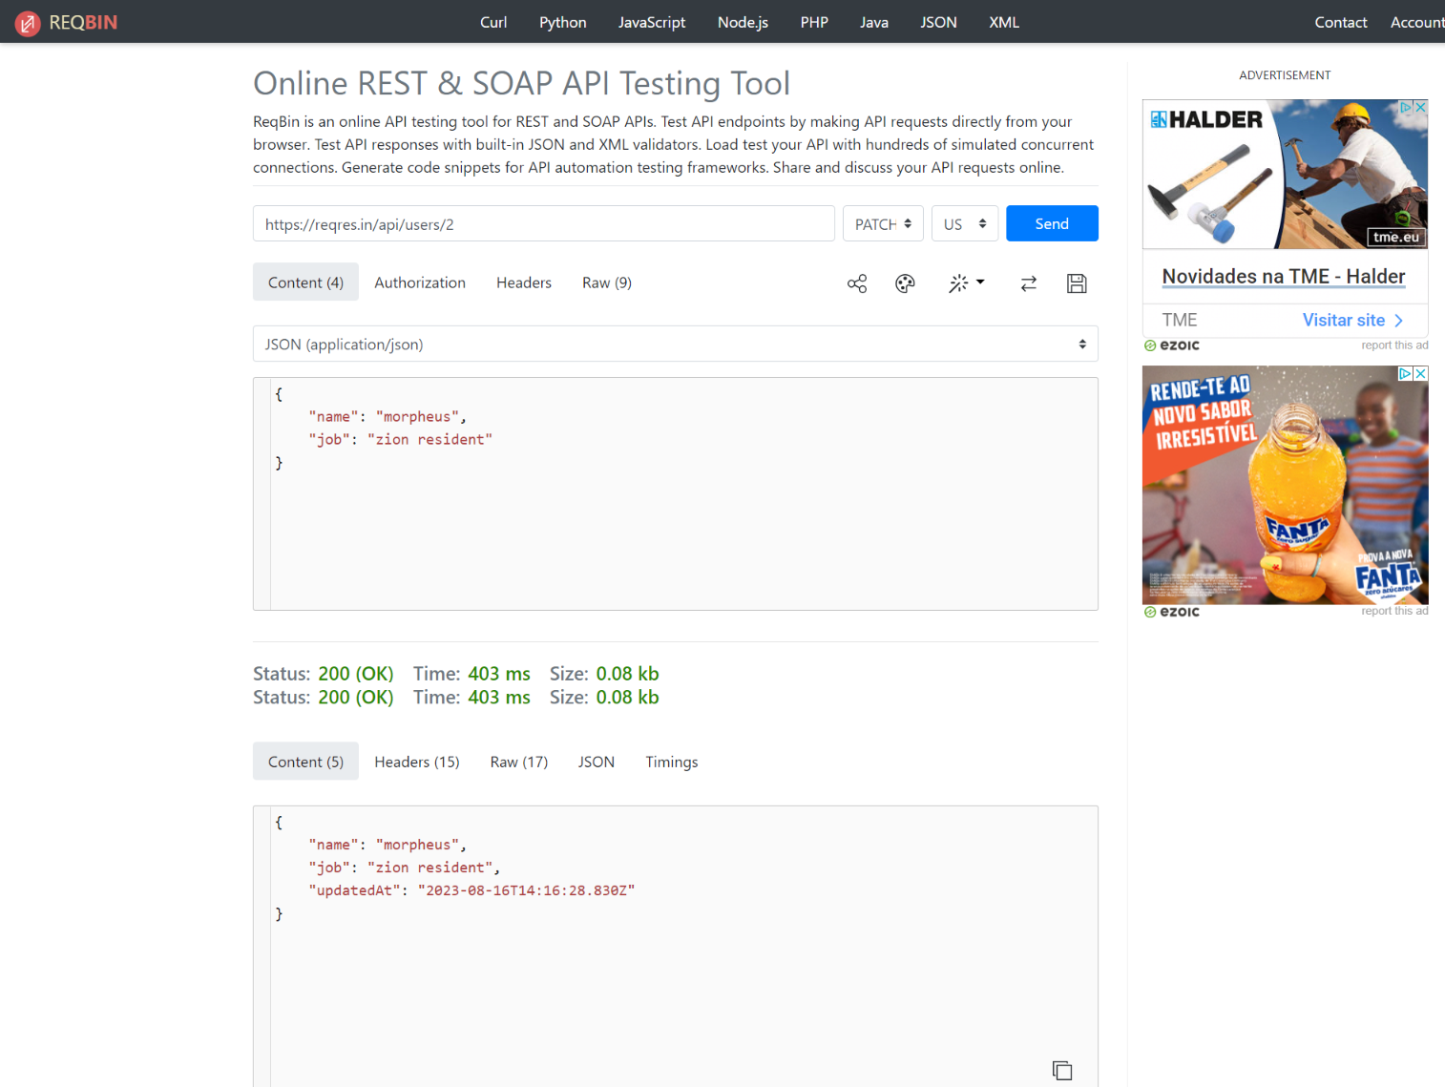

Users info after update (by PATCH method):

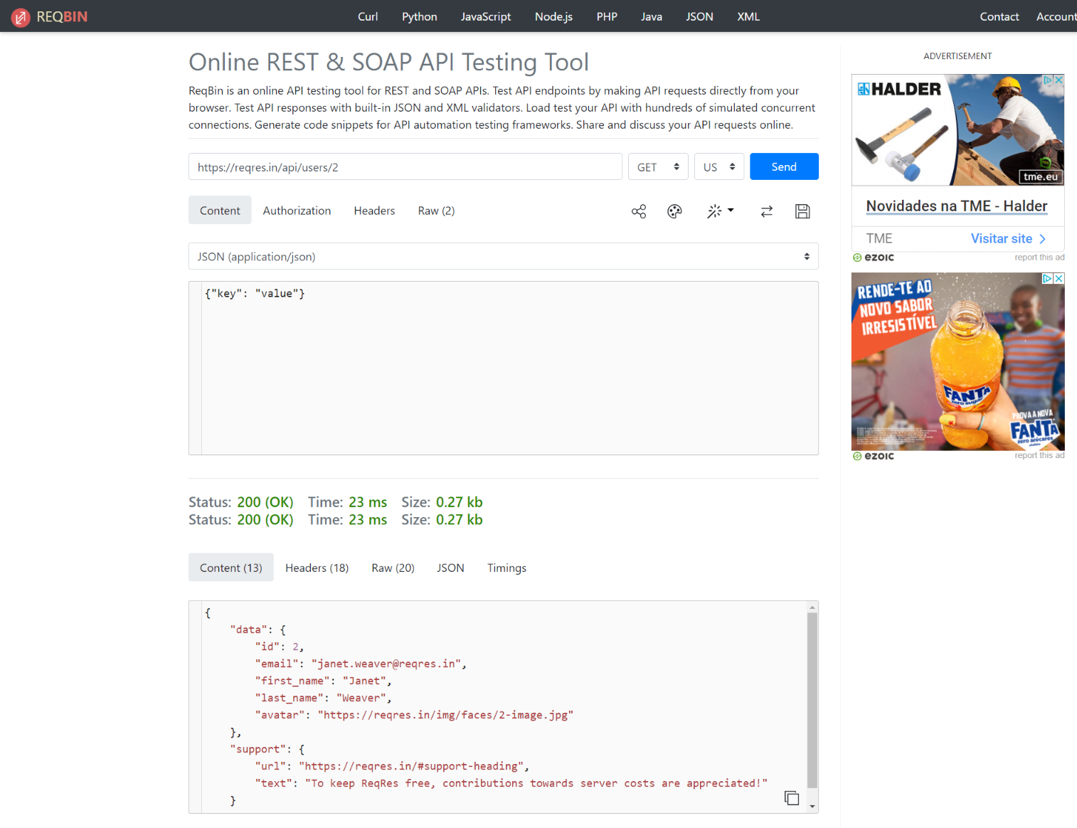

| **Bug ID** | B4 |
| --- | --- |
| **Title** | User is not deleted |
| **Description** | After using the DELETE method to delete an user, the user is not deleted and is possible to consult its information through the GET method |
| **Environment** | Lenovo ThinkPad; Windows 10 Pro; Google Chrome Version 115.0.5790.173 |
| **Steps to Reproduce** | Delete any user using the DELETE method on the link [https://reqres.in/api/users/](https://reqres.in/api/users/%7Buser){user ID];  Use the GET information on the link <https://reqres.in/api/users/>{user ID} using the previously deleted user ID |
| **Screenshots** | Below |
| **Expected Result** | The user doesn’t exist anymore - 404 error |
| **Actual Result** | The user is not deleted and it is possible to get its information through the GET method |

User’s deletion:

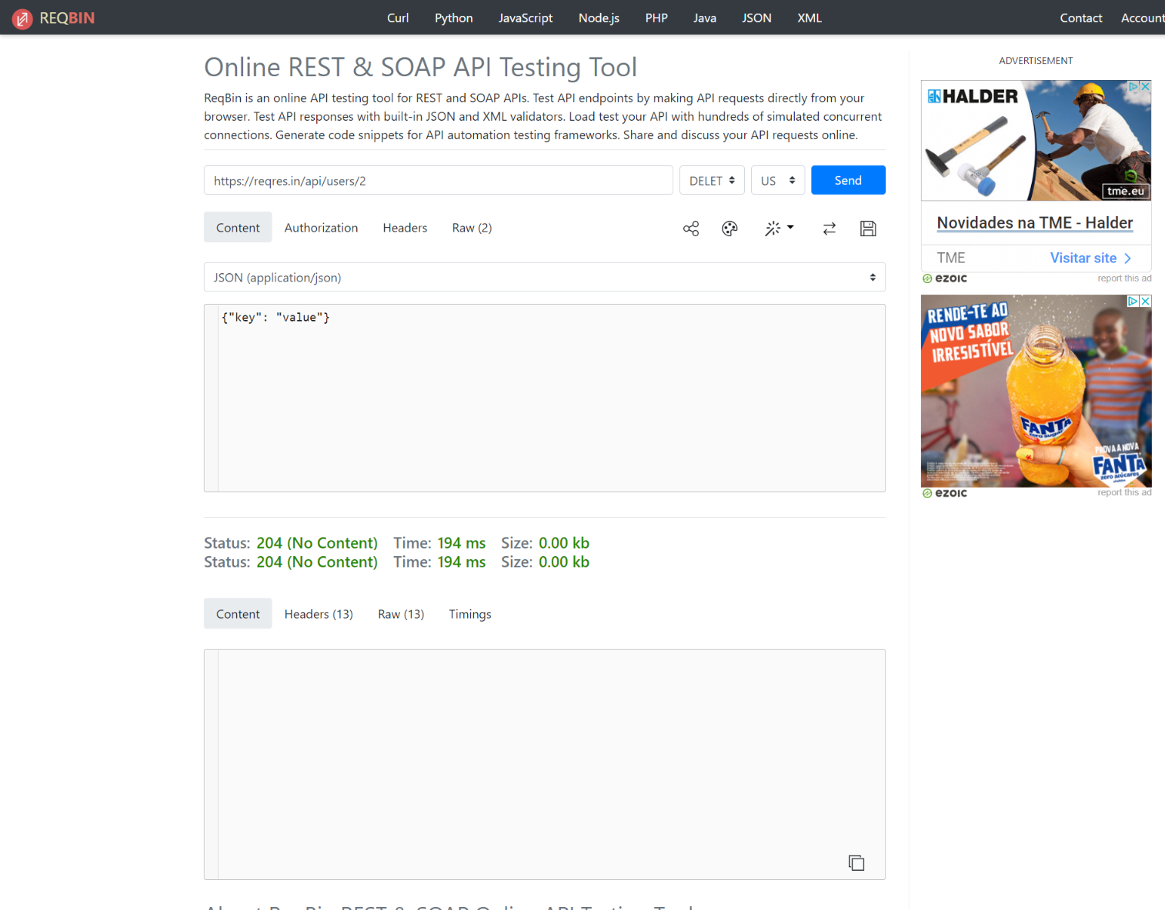

User’s information after deletion:

